**Wednesday, September 11, 2024**

**9:30am – 4:00 pm** Golf Tournament at Bear Mountain, Chelan, WA:   
 Four-person best ball scramble

**Thursday, September 12, 2024**

Morning Sessions Moderator:

Stephanie Smith, WAFFP President

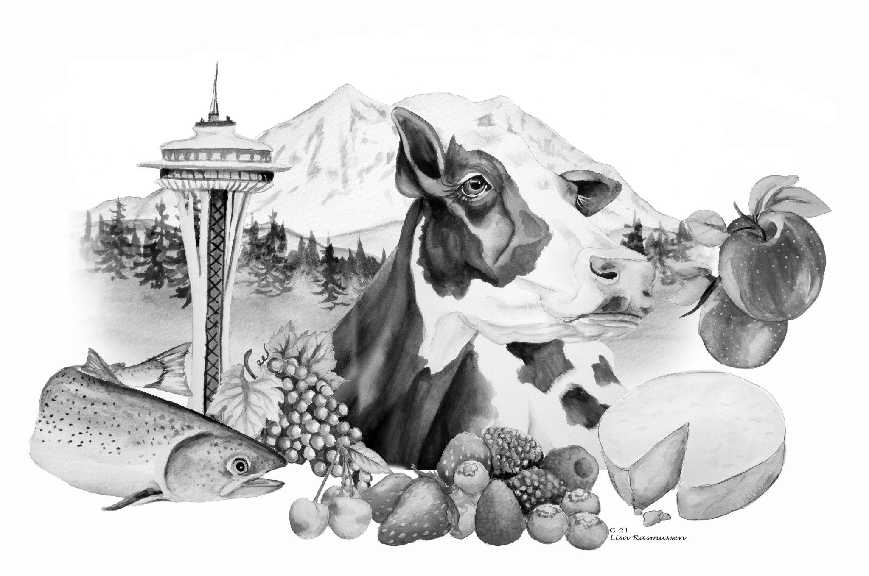

**7:15 – 8:00 am** *Check-in / Breakfast*

**8:00 – 8:15 am Welcome**

**Luedecke Scholarship Winners**  
 Stephanie Smith, WAFFP President

**8:15 – 8:45 am 100th year anniversary of PMO**

Stephanie Olmsted, Retired

**8:45 – 9:20 am WSU Creamery Past, Present and Future**

John Haugen, WSU Creamery

**9:20 – 10:05** **FDA Infant Formula Updates**

Latasha Robinson, FDA

**10:05– 10:15 am** *Supplier presentation*

**10:15 – 10:30 am** *Milk Break*

**10:30 – 11:15 am WSDA Food Safety Program Update**

David Minor, WSDA Food Safety

**11:15 – 12:00 pm WSDA Animal Feed Program Update**

Michelle Riddle & Vianca Philpotts, WSDA Animal Feed Program

**12:00 - 12:10** *Supplier Presentation*

**12:10 - 1:15 pm** *Lunch*

Afternoon Sessions Moderator:Stephanie Smith,WAFFP President

**1:15 – 2:00 pm “Washington Grown” – Telling the Story of Food and Agriculture**

Chris Voigt, Washington State Potato Commission

**2:00 – 2:45 pm Label Claims, Food Fraud and Technology**

Nidal Kahl, BIOGEN Labs

**2:45 – 2:55 pm** *Supplier Talk*

**2:55 – 3:10 pm** *Milk Break*

**3:10 – 4:30 pm Food Safety Culture Panel**

Girish Ganjyal, WSU

Connie Fisk, WSDA

Nada Hasbini, Whole Foods Market

Bruce Odegaard, Seafood Products Association

**4:30 – 5:30 pm** Business Meeting

**6:00 – 7:00 pm** Student Poster Presentations -   
 Science and Cocktails Happy Hour   
 with the Students

**7:00 – 8:00 pm** Dinner & Awards Banquet

**Friday, September 13, 2024**

Morning Sessions Moderator:   
Stephanie Smith, WAFFP President and Kent Dowding, WAFFP President-Elect

**7:00 – 7:45 am** *Breakfast*

**7:45 – 7:50 am Welcome**

Stephanie Smith, WAFFP President

**7:50 – 8:05 am Growth and Enterotoxin Production of Bacillus cereus in Rehydrated Infant Milk Formula, Non-fat Dried Milk, and Whole Milk Powder under Different Storage Conditions**

Sathish Yerrapati, WSU

**8:05 – 8:20 am Multidisciplinary investigation of Rhizophagus intraradices on soil mycobiome and strawberry quality**

Hoang Ngoc M. Le, OSU

**8:20 – 8:35 am Does the Fresh Rice Noodles on the grocery shelves make you sick?**

Barakatullah Mohammadi, WSU

**8:35 – 9:15 am 2023 Foodborne Outbreaks and Lessons Learned**

Waimon “Meelay” Tellier, MPH –Washington Dept. of Health

**9:15 – 10:00 What Now Dairy Cow? HPAI Updates**

Dr. Amber Itle, Washington State Veterinarian

**10:00 – 10:10 am** *Supplier Presentation*

**10:10 – 10:25 am** *Milk Break*

**10:25 – 11:10 am Mitigating Avian Influenza for Processors**

Jordan Rocke, Litehouse Foods

**11:10 – 12:00 pm Foodborne Illness Litigation**

William D. Marler, Marler Clark

**Noon – 1:00 pm Lunch** and **“Passing of the Gavel” to the incoming WAFFP President**

**1:00 pm Adjourn** – Safe travels home and see you next year!